**Pothole Patching Robot For Road Maintenance Automation**

**Objective:**

Potholes are a big problem, especially in developing countries, and they can lead to vehicle injuries or physical injuries for vehicle owners and passengers. Maintenance agencies can be warned to take precautionary & measures if real holes are found in the real time. Their place can be entered and shared to assist road repair structures. Moreover, it is very difficult to quantify the content for which and what is needed to fill a wide-ranging road pit and estimate the time required for filling a pit in mean time, here the major problem is our maintenance organizations leads to delayed repairs and additional costs. This project suggests a way to a car-based computer viewing system to identify holes using a mounted camera with the help of this, links to pothole can be found and we can feed that data in Mat lab with the help of a different conversion matrix to get the result you want imitation. Existing books obtained by pothole use models of overlay constructed pits that are time taking process, hard-working and extremely expensive and ineffective. The distinguishing feature of the work presented in this project is that complete work is being done to create a working space for the Cartesian robots of the underground tunnels under various conditions, and the results are obtained using mat lab. Robot Motion is available with a rack and pinion mechanism. Using this method, it is possible to find mineral holes with high accuracy and save time, innovation and cost.

**Hardware & Software Requirements:**

1. **Raspberry-pi**
2. **NEMA 17 stepper motor**
3. **Arduino Nano**
4. **TB6560 Driver**
5. **NRF2401A Transceiver**
6. **12v DC Power supply SMPS**
7. **DC geared Motors**
8. **Threaded Rod**
9. **pulleys and bearings**
10. **Wooden Support**
11. **Aluminum Frame**
12. **Metal Chassis**

**Project Flow:**

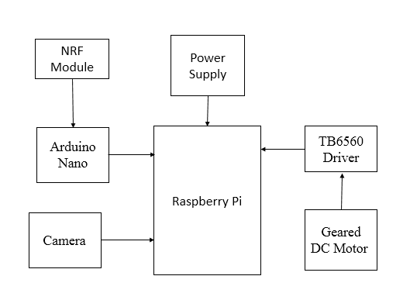

The system operator will align the system on the road such that the pothole lies between the working areas of the system. After aligning the system, the system will capture the image of the entire working area. This image will be given as a input to Raspberry-Pi. Using Image-Processing the size of the pothole will be determined and the exact co-ordinates and location of the pothole will be calculated. This co-ordinates will be used by the pothole cleaning mechanism to clean the debris inside the pothole. The cleaning process will be done by the system autonomously. After the pothole is cleaned the system operator will align the flow control mechanism over the pothole and fill the pothole with dry asphalt material which will be already stored in the system. After filling the pothole with dry asphalt material, the system operator will drive the system over the pothole. By driving the system over the pothole the pothole will get compacted by the weight of heavy roller present at the back of the system. Once the pothole is compacted we have temporarily patched pothole and the road can be used for commutation. The entire process will take around 10-15 minutes while providing us with a temporary solution for busy hours when there is heavy traffic without causing any inconvenience to the commuters. The pothole can then be permanently repaired when the traffic is less.

**Proposed System:**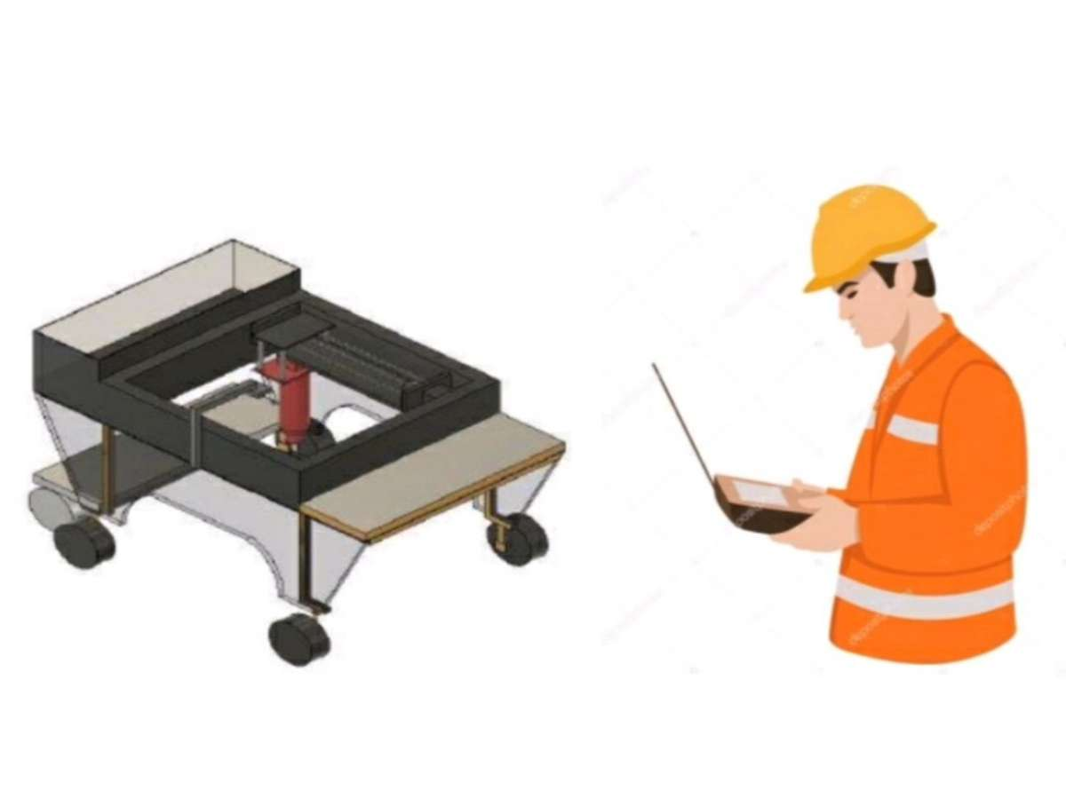

**Stakeholders:**

The first consumer would be the Local authorities who are in charge of the road maintance. Since the project’s main concept is to complete the following task in less time and prevent chaos. Second comes the industries who work in the combination of Civil and mechanical dept. with help of these models, they can develop a model in a precise manner such as usage of alternate elements for making of road, etc. Then come the researchers which combines all the dept in order to make the prototype work in an efficient way such that it would work in an the cities and places where there is any hole on the road.